SENIOR LEADERSHIP CONFERENCE
1st – 3rd July 2020
Armathwaite Hall, Keswick, Lake District, CA12 4RE
Target audience
1st July 2020 Deputy and Assistant Head Teachers
2nd July 2020 Head Teachers, Deputy and Assistant Heads
3rd July 2020 Head Teachers

Speakers
1st July 2020 Jonathan Lear, “There’s doing what’s right and there’s doing what you’re told. You choose”
2nd July 2020 Art of Brilliance – Brilliant Leadership
3rd July 2020 Graeme Lucas from Lancashire School Improvement Service & Primary and Special Heads Meeting

Conference Rates – for all Blackpool schools
2 day delegate Wed/Thurs or Thurs/Fri including conference, lunch and refreshments, one night BB and evening meal - £130.00 per person

Conference Rates – for all Lancashire schools
2 day delegate Wed/Thurs or Thurs/Fri including conference, lunch and refreshments, one night BB and evening meal - £230.00 per person

Also includes use of onsite Health Club at Armathwaite Hall.

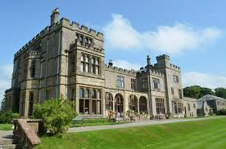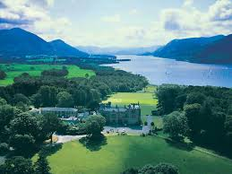

Book online at: https://www.blackpoolteachingschoolalliance.org.uk/courses

