SENIOR LEADERSHIP CONFERENCE
30th June – 2nd July 2021
Armathwaite Hall, Keswick, Lake District, CA12 4RE
Target audience
30th June 2021 Deputy and Assistant Head Teachers
1st July 2021 Head Teachers, Deputy and Assistant Heads
2nd July 2021 Head Teachers

Speakers
30th June 2021 Jonathan Lear, “There’s doing what’s right and there’s doing what you’re told. You choose”
1st July 2021 Art of Brilliance – Brilliant Leadership
2nd July 2021 Graeme Lucas from Lancashire School Improvement Service & Primary and Special Heads Meeting

Conference Rates – for all Blackpool schools
2 day delegate Wed/Thurs or Thurs/Fri including conference, lunch and refreshments, one night BB and evening meal - £130.00 per person

Conference Rates – for all Lancashire schools
2 day delegate Wed/Thurs or Thurs/Fri including conference, lunch and refreshments, one night BB and evening meal - £230.00 per person

Also includes use of onsite Health Club at Armathwaite Hall.

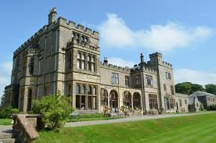

Book online at: https://www.blackpoolteachingschoolalliance.org.uk/courses

