Speech, Language and Communication Champions Network Meeting
Cost: FREE to all BTSA Blackpool Schools
£20 for non BTSA Schools
Initial meeting: Tuesday 21st May 2019 3.45-4.45pm
at Park Community Academy
‘’In many schools, particularly those in areas of social disadvantage… pupils have delayed speech, language and communication skills. This means that they aren’t equipped with the language that they need to access the curriculum effectively.’’ The Communication and OFSTED Framework
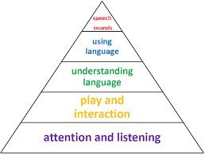
Teaching staff have a very important role to play in supporting all children’s speech and language development and identifying when they might be having difficulty. This new network will;
- Enable schools to build communication supportive environments
- Support training needs of staff
- Discuss the challenges faced by pupils with speech, language and communication difficulties
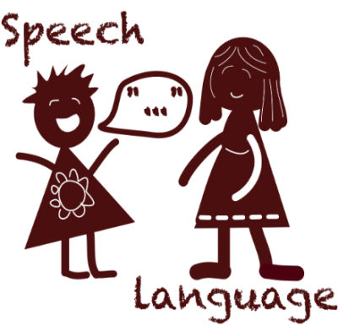
- Share effective practice between schools and signpost champions to high quality classroom resources .

If you wish to book a place please email
Catherine.Cole@st-nicholas.blackpool.sch.uk
Network meetings will be termly 3.45-4.45pm
Future Meeting Dates:
Wednesday 25th September 2019, Thursday 23rd January 2020, Tuesday 28th April 2020
ALL welcome!

